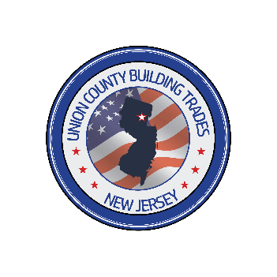

Building & Construction

Trades Council

of Union County

Please join us in our 1st annual celebratory Beefsteak gathering
honoring the late,
John Malcolm.

Thursday, May 8th, 2025 from 5 – 8 p.m.
Kenilworth V.F.W.
33 S 21st St, Kenilworth, NJ 07033

Pricing options:

Per guest $50.00
Friend Sponsor $150.00 ( Includes 1 Entry Ticket )
Gold Sponsor $300.00 ( Includes 2 Entry Tickets )
Beverage Sponsor $500.00 (Includes 3 Entry Tickets )
Platinum Sponsor $1,000.00 ( Includes 5 Entry Tickets )

Name/Organization____________________________________________________

Address______________________________________________________________

Phone Number/Email___________________________________________________

Sponsorship Level______________________________________________________

Number of Tickets______________________________________________________

Amount Enclosed_______________________________________________________

------------------------------------------------------------------------------------------------------------------------
PLEASE ENCLOSE TOP PORTION WITH CHECK

Please make all checks payable to: Building and Construction Trades Council of Union County.
700 Swenson Drive
Kenilworth, N.J. 07033

*Please respond to Union County Building Trades Secretary Treasurer, Jason Rooney (908) 337-1773 with a head count by Friday, April 11, 2025.
* Email all logo PDF’s for the sponsorship board to jrooney@smwialu22.org

